|  |
| --- |
|  |
| A CASE STUDY DONE TO IDENTIFY THE FACTORS DETERMINING STUDENTS EDUCATIONAL DECISIONS AND HOW AI CAN HELP STEER STUDENTS IN THE RIGHT PATH. |
| |  | | --- | |  | |

# Abstract

The absence of a methodology in the current education system to guide students when it comes to making educational decisions have left several students stranded or depend on irrational factors. The population of this research study are the students in the following education level.

* Grade 10 -11 (O/L)
* Advance level students
* University 1st year students
* University 2nd year students
* University 3rd or final year students

Because it is impossible to reach the entire population and good random sample will be used to estimate the population parameters. The independent variable identified in this research study are education system, external factors, individual’s influence, and satisfaction. The dependant variable of this study is motivation. Questionnaire with Likert scale will be distributed in-order to collect data and find relationship and correlation between the variables.

And finally depending on the significance of the relationship and correlation we can either accept or reject the null hypothesis. The main objective of this study is to show that student often make wrong decisions based on irrational factors and suggest a methodology such as Artificial intelligence which would help student make rational decisions based on their skills and talent.

Contents

Abstract 1

Acknowledgement 2

**1. Introduction** 6

**1.2 Background** 6

**1.2 Problem Statement** 7

**1.3 Purpose/Aims/Rationale/Research Questions** 9

**2. Literature Review** 12

**3.** **Research Methodology and Design** 13

3.1 Introduction 13

3.2 Research Methodology 14

Observational study 16

Simple regression Analysis and Multiple regression analysis 17

3.3 Conceptual Framework 18

Independent variables 19

Dependant variable 22

Hypothesis 23

Conceptualization 25

Preliminary data collection 28

Method of data collection 29

Chapter 4: Data Analysis and Discussion 30

Introduction 30

Data coding 31

Data Distribution 32

Gender 32

Level of study 34

Education attained from 35

Descriptive statistics 36

Education System 37

External factors 38

Individual’s influence 39

Satisfaction 40

Motivation 41

Change in human ecology (Data collected to find out the number of students willing for a new human ecology) 42

Normality test for each Variables and change in human ecology. 43

Education System 43

External Factors 44

Individual’s influence 45

Satisfaction 46

Motivation 47

Change in human ecology 48

Conclusion 49

Testing Hypothesis 50

Motivation vs Education system 50

Motivation vs External factors 52

Motivation vs Individual’s influence 54

Motivation vs Satisfaction 56

Summary of Hypothesis Testing 58

Chapter 5: Conclusion and Recommendation 59

Introduction 59

Recommendation 61

Bibliography 62

Appendices 63

**Table of Figures**

Figure 1 correlation coefficient 17

Figure 2 Conceptual Framework 18

Figure 3 Gender Pie-chart 32

Figure 4 Age Pie-chart 33

Figure 5 Level of study Pie-Chart 34

Figure 6 Education attained from Pie-Chart 35

Figure 7 Educations system Histogram 37

Figure 8 External Factors Histogram 38

Figure 9Individual's influence Histogram 39

Figure 10 Satisfaction Histogram 40

Figure 11 Motivation Histogram 41

Figure 12 Change in human ecology Histogram 42

Figure 13 Education System normality test 43

Figure 14 External Factors normality test 44

Figure 15 Individual's influence normality test 45

Figure 16 Satisfaction normality test 46

Figure 17 Motivation normality test. 47

Figure 18 Change in human ecology normality test 48

Figure 19 Regression for Motivation vs Education System 50

Figure 20 Relationship between Motivation and Education System 50

Figure 21 Correlation between Motivation and Education System 51

Figure 22 Regression for Motivation vs External factors 52

Figure 23 Relationship between Motivation and External factors 52

Figure 24 Correlation between Motivation and External factors 53

Figure 25 Regression for Motivation vs Individual’s influence 54

Figure 26 Relationship between Motivation and Individual's influence 54

Figure 27 Correlation n between Motivation and Individual's influence 55

Figure 28 Regression for Motivation vs Satisfaction 56

Figure 29 Relationship between Motivation and satisfaction 56

Figure 30 Correlation between Motivation and satisfaction 57

# **1. Introduction**

## **1.2 Background**

Artificial Intelligence is all about expecting machines to exhibit human intelligence, use of the word AI has been around for around sixty years back in the days even though the idea was there it wasn’t feasible due to a number of constraints. Thanks to the advancement in internet and machineries AI has become a reality. Typically, machines work by following a set of hand-coded software routines to accomplish a specific task. But the most efficient way would be to make machines learn rather than coding several codes. In-order to make machine learning possible there are two major requirements they are a huge amount of data and high-performance computers. Machine learning a branch of AI at its most basic is all about providing machines with data in-order to get meaningful predictions. In-order to get meaningful predictions machines are provided with a massive amount of training data. AI has become very much an integral part of our lives; our world is pretty much running on artificial intelligence. Siri manages most of our activities. YouTube recommends us what to watch. Facebook suggests our friends. We have self-driving cars, and air traffic control is mostly fully automated. Virtually every field we could take into consideration has benefited tremendously due to the advancement in artificial intelligence, right from the military to manufacturing to medicine have and are benefiting from AI.

Even though AI has contributed several fields massively when it comes to education it has been lagged. Unfortunately, the momentum for artificial intelligence in education seemed to have faded in the past few years and failed to contribute to the field of education considering the potential AI has got to offer. We are pretty much stuck to cookie cutter approach, treating all students the same manner in the classroom. Machine learning can be used to find patterns in data provided regarding the performance of the student’s in-order to help steer them in the best possible direction depending on the talent of a particular student such as.

* + Physical Activities
  + Mathematics and Science
  + Music
  + Languages
  + Humanities
  + Arts
  + Dancing
  + Etc.

And help in several other ways. Therefore, AI should be used in education which would eventually help in preventing students follow the wrong path.

## **1.2 Problem Statement**

Students have often struggled during primary education and selecting majors. Because the way a traditional academic model is structured. If we consider a math test for an example and assume that the students’ scores 75, 80, 90 and etc. and the whole class will move on to the next lesson with gaps of 25, 20, 10 and so on. This pattern will continue, and the gaps will increase for most of the students because most of what we study are interconnected, and the fundamentals are the key. And eventually the student might end up hitting a wall. It is not because of the inability of the students or because of the fundamentals of math is difficult. Another area where students struggle is when it comes to choosing the right major based on what they are naturally good at. The goal of this work is to emphasize on the possibility of machine learning a branch of AI can contribute tremendously on the education sector by identifying the gaps students might have and assist them by providing them with custom material, exercises and lessons that can help them bridge those gaps. The same algorithms can be used to identify the strengths and talents in students and help them select majors that they are most likely to perform the best.

**Some of the major issues identified in the current education system are.**

* Every education system on earth has pretty much the same hierarchy of subjects.
  + Mathematics and Science
  + Languages
  + Humanities
  + Arts

Above mentioned hierarchy is rooted on the idea, the most useful subject for work are at the top. So students were probably steered benignly away from where their strength lies because of various reasons such as peer pressure, pressure from parents, fear of that you would not get a job on the ground and etc. could steer students in completely wrong majors. And the consequence is that many incredibly talented, brilliant, creative people students think they are not, because the things they were good at was not valued or stigmatized.

* Cookie cutter approach, treating all students the same manner in the classroom. Human beings are naturally different and diverse, so cookie-cutter approach is highly not recommended.
* Schools encourage students to find out what they can do across a very narrow spectrum of achievement. A real education must give equal weight and emphasis to the different fields in education. And work out where the curiosity of the student is, students prosper best with a broad curriculum that celebrates their various talents, not just a small range of them.
* Teachers often act as a delivery system. The job of a teacher is not just to pass a received information, which is important but what great teachers also do are.
  + Identity the strengths and weaknesses of the different students.
  + Should know where to emphasize and where to play down.
  + Mentor, stimulate, provoke, and engage.

Teachers can be considered as the lifeblood of the success of schools. Teaching is a creative profession; teachers play a pivotal role in shaping the future of students.

* Testing been the dominant culture of education over teaching and learning. Testing is important, but they should not be the dominant culture of education. Tests are often summative used to monitor the students, but tests should be diagnostic, in other words they should help educate students.

# **1.3 Purpose/Aims/Rationale/Research Questions**

My objective is to use the potential of Artificial Intelligence (AI) to make a difference in the field of education. As I mentioned earlier almost all fields have benefited from AI, unfortunately education has lagged even though AI has a lot of potential to contribute to the field of education. AI has the potential to help education in the following areas.

* Customized courses and material

Up until now, teachers and schools were forced to use cookie cutter approach, treating all students in the same manner in the classroom. This is not the most effective way of teaching by far simply because all students aren’t equal. Until now, it has been the case because it was practically impossible to provide different materials and courses. Machine learning a branch of AI has made it possible by identifying patterns in data which will help teachers provide students effective and relevant materials depending on the requirements of the different students by identifying where a student is having trouble and help them bridge those gaps.

* Helping teachers fill the gaps in education

Above mentioned mechanism can help the teachers as well by proving them a clear picture of where to emphasize and where to play down. Which would eventually help the students move forward with less gap areas. Teachers will eventually identify the strengths and weaknesses of students and mentor, stimulate, provoke and engage students depending on their individuality.

* Identify the most appropriate major

Until now, students very rarely select majors depending on what they are naturally good at. Students often make this vital decision because of their friends, parents, and lack of knowledge, various other factors, and mainly due to the unavailability of a mechanism that would steer them in the correct path by identifying possible strengths and talents of the students. Now, thanks to machine learning, it can use its algorithms to find and prescribe appropriate learning paths to students and make sure that they will enjoy the journey to building their career.

* Simplify the huge amount of data into useful information

Until now, higher education students are fed a massive amount of data not necessarily the essence of information that is required by them. Content Technologies has been exploring this concept of turning big data into information and information into knowledge this mechanism is called deep learning which a subset of machine learning is.

* Analyze tests

Common practice in schools is that tests are not formative they are summative, usually used to monitor the students not to educate. AI can be used to analyse fed test data and provide useful information to the teacher in-order to help them educate the students.

* Encourage schools to give equal weight to the different fields of education.

The moment students start to select fields based on their curiosity, individuality, and their curiosity with the help of AI and not letting other variable dictate terms. Schools, colleges, and universities will have no option but to give equal weight to different fields.

Online tutoring is another massive sector that has taken advantage of AI. Students from all over the world have benefited a lot, thanks to broadband internet and the explosion of cloud computing. Now, thanks to AI, these platforms are moving to the next level, connecting to the right people are enhancing tutoring experience. Some popular tutoring platforms that use AI are.

* Coursera
* Brainly
* Third Space
* Etc.

But this research study will not address online tutoring, even though AI has contributed to online tutoring.

The research question that will be solved during the study are.

* What is the potential of Artificial intelligence in education (AIED)?
* What are the problems in the current education system?
* What factors determine students’ selection of major?
* Who influences the student's major selection?
* How comfortable is the student in their declared major?
* What percentage of the population would need a new concept of human ecology?

Answers to the above research question are to be found in this research project.

# **2. Literature Review**

Literature review is all about taking the major concepts from major works of authors such as book, articles, websites etc. which go along the selected narrow research topic. And finally forming relationships between the major concepts.

The fact that all students are different has been emphasized by other studies also, Artificial Intelligence can provide an intelligent, Rose Luckin, Wayne Holmes, Mark Griffiths, and Laurie B. Forcier (2016) have emphasized on personal tutor for every learner. One to one tutoring has always been one of the most efficient approach when it comes to teaching and learning. But was impossible due to the impracticality of one-to-one tutoring because of the various constraints it come up with such as affordability and lack of resources. This is where Intelligent Tutoring Systems (ITS) come into the play. ITS use AI techniques in-order to stimulate on-to-one human tutoring, providing learning activities best matched to learner’s cognitive needs and delivering timely feedback all of it without an individual teacher present. (Rose Luckin, Copyright 2016). Similar article is produced by Ben Dickson (2017). He states that similar material and courses should not be provided to different students, students should be provided by customized courses and materials this can be done using AI. Which could be considered as a much more efficient methodology to be followed. (Dickson, 2017). Rose Luckin, Wayne Holmes, Mark Griffiths and Laurie B. Forcier talks about an ITS, which is an AI technique to stimulate one-to-one human tutoring. On the other hand, Ben Dickson is emphasizing on the fact that different learners should be provided with customized courses and material. We can conclude Even though the technicality book and the article differs both revolves around the fact that different learners should be provided with customized courses and material and tutoring.

# **Research Methodology and Design**

## 3.1 Introduction

This chapter would provide some enlightenment on whether there is a need for a change in the current education system which would appreciate the fact that all human beings are naturally different and diverse. The purpose of this research is to identify the flaws in the current education system and propose technique which would help mitigate the current issues in the education system.

As this research focuses on students, they are the population of this research. In-order to collect the data required for this research a survey must be conducted because it is almost impossible to reach the whole population because of several factors such as time, cost and feasibility. The survey must be done for a random sample in order ovoid bias in our response, in-order for it to have the best chance of it being indicative of the entire population. Data is expected to be collected through questionnaires (which is a primary research technique which would help answer specific issues or questions) and by manipulating pre-exiting statistical data (which is a secondary research technique which makes use of information already publicly available).

The independent and dependant variables must be found and represented on a conceptual diagram also known as theoretical framework. After the independent and dependant variable are found hypothesises can be set up to find whether there is any causal relationship between each independent variable and the dependant variable.

Main intention of this research is to solve the problem of the population as in most of the researchers. But because it is not feasible to go to every member of the population as discussed earlier. So, we’ve decided to conduct a survey on a random sample to estimate correlation between parameters this process is called preliminary analysis. Advance analysis or inferential analysis is done after the preliminary analysis to estimate the population parameters. Assumption about the population parameters (hypothesis) can be made when there is a significant amount of sample correlation coefficient. Preliminary analysis and advance analysis will be done in the following chapters.

## 3.2 Research Methodology

This research is going to be conducted in-order to sort out a major problem in the current education system (the issues have being discussed in the previous chapters) with the help of machine learning a branch of Artificial Intelligence. First and foremost, I’ve to figure out whether AI has the potential of becoming the solution for the current that is identified in our education system. In-order to conclude whether AI has what it takes to provide an efficient solution some research was done.

As I’ve identified the problems within the education system, the population of my research are the students (ideally from primary education). Survey has been conducted in-order validate the problems identified in the education system. One option is to go to every member of the population but because of the population is so high it is impossible to reach the whole population. Survey has been done on sample to get an indication of how the entire population feels about the current education system. In-order to avoid having any bias in our response, in-order for it to have the best chance of being indicative of the entire population our sample had to be truly random.

**Following methodologies had to be taken in-order to make sure the sample was truly random.**

* Simple random sample

A simple random sample is all about selecting a random from the entire population. Because it is impossible to reach the entire population a random sample (random sample>30) from the sample could be done. In-order to get a simple random sample form the sample a random number generator could be used. Using a random number generator will give us a certainty that the students picked are random. It is unlikely to have bias from this sample, but there is some probability that just by chance the random number generator could select a disproportionate number of boys over girls, or disproportionate number of other variables. So, there is some probability that the simple random sample won’t be indicative of the entire population. So, to mitigate that probability;

* Stratified sample

Stratified sample is all about taking the entire population and essentially stratifying it. Because it is not feasible to stratify the entire population a stratified sample (random sample>30) from the sample could be done. In-order to get a stratified sample form the sample we must stratify the sample these are the stratifications.

1. Grade 10 -11 (O/L)
2. Advance level students
3. University 1st year students
4. University 2nd year students
5. University 3rd or final year students

There should not be a huge disproportionate number of boys over girls (80% to 20%) or the other way around in stratified sample. Now instead of just getting a simple random sample, we get a specific number of sample from each of the above mentioned stratifications, In-order to make sure that we will end up with an indicative response from at least all of the different age groups and gender. There are other techniques such as clustered sampling which could help increase the quality of sample.

#### Conclusion

The form of random sample technique that I have used is stratified sample in-order to increase the chances of the sample being indicative of the entire population. Using a good random sample technique could avoid us falling into pitfalls that could introduce bias such as.

* Voluntary survey
* Convenience
* Wording
* Response bias
* Etc.

Stratification was done to the best of abilities to avoid any bias in-order to make the response indicative of the population.

### Observational study

An observational study for the random sample can be done to estimate the correlation between the independent variables and dependant variable or independent variable and dependant variable. An observational study has being done in-order to observe a relationship, the is called the simple correlation coefficient, but at this stage it is not really possible to accept the alternative hypothesis and say there is a causal relationship between the independent variable and dependant variable.

* Null Hypothesis: H0 = There is no correlation
* Alternative Hypothesis: H1 = There is correlation

Here the hypothesis test is done for the population, the population correlation coefficient = ρ, therefore the above hypothesis could be written as.

* H0 = ρ = 0
* H1 = ρ ≠ 0

We can use Minitab to calculate the sample correlation coefficient between variables. The sample correlation coefficient will be represented by “r”, if.

* r = 1 Perfect Positive correlation
* 0.5< r > 1 Strong positive correlation
* 0 < r ≤ 0.5 Weak/Moderate correlation
* r = 0 No correlation
* 0 < r ≥ -0.5 Weak/Moderate negative correlation
* -0.5 > r > -1 Strong negative correlation
* r = -1 Perfect negative correlation

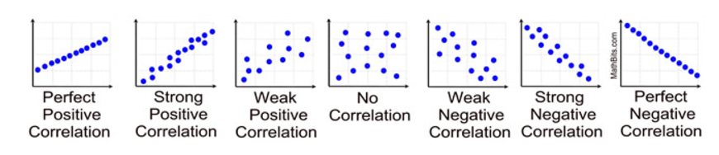

Figure correlation coefficient

The statistical studies are done for a confidence level of 95%, therefore significance level = 0.05 (α = 0.05), therefore whenever.

* P > α Accept H0
* P < α Accept H1

#### Conclusion

Observational study is done to estimate a correlation between two variables, if there is a significant amount of sample correlation coefficient (r ≠ 0), we have to accept the alternative hypothesis (H1), which mean that the population correlation coefficient is not equal to zero (ρ ≠ 0), if there isn’t a significant amount of sample correlation coefficient we can accept the null hypothesis (H0).

## Simple regression Analysis and Multiple regression analysis

And finally, if there is a significant amount of correlation, we can do a simple regression analysis and multiple regression analysis. If there is not a significant amount of correlation, there is not point of doing regression analysis. Simple regression model can be used to do by variant statistic,

**Simple regression model 🡪 Y = B0 + B1X1**

Ex: Pressure vs Selection of major.

Multiple regression analysis can be used to test the combined impact of independent variables on the dependant variable.

**Multiple regression model 🡪 Y = B0 + B1X1 + b2X2**

Ex: Pressure and reputation vs Selection of major.

## 3.3 Conceptual Framework

This research was conducted to understand factors influencing student major selection and provide a solution using a branch of AI called as machine learning. The theoretical framework was developed based on the knowledge gained from research and intuition. The theoretical framework was developed to explain to explain the researcher various parts of the formal theories. The “Why” and “How” the phenomenon might work.

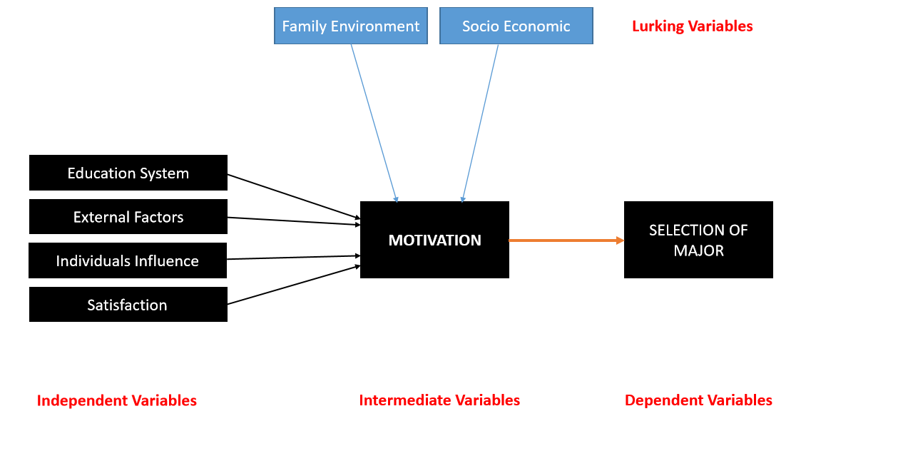

Figure Conceptual Framework

### Independent variables

Independent variables are the factors identified by the researcher that could have an impact on the dependant variable. The dependant variables that were identified by the researcher are explained below.

Education System

The education was identified by the researcher as an especially important independent variable in the study. Students could well and truly end up successful if their skills were identified and encouraged instead of disesteem or stigmatize.

The dimensions/sub factors identified for this independent variable are.

* Delivery method: the delivery method should not be the same for different students as per the understanding of the researcher in-order to give the best possible chance for the students to be guided in the correct path.
* Completion /Incompletion: Students have often struggled in the later grades because of the fact they have continued with gaps.
* Technologies: computers, mobile devices, and other technologies used can have an impact on student motivation.
* Pedagogical Strategy: In 1986, Lee Shulman an educator and researcher noticed that all students need a teacher who is more than knowledgeable about their subject. Combination of content and teaching/pedagogy is known as pedagogical content knowledge, it will help student learn efficiently.
* Hierarchy: Most of the education system on earth have pretty much the same hierarchy of subject, and the consequence is that many incredibly talented, brilliant, creative people think they are not.
* Test: Dominant culture of education has become test not teaching and learning. Mostly are not diagnostic.
* Teacher: the role of the teacher is to facilitate learning and make students motivated.

External factors

External factors were identified by the researcher as another especially important independent variable in the study. Specifically, environmental influence and career opportunities.

The dimensions/sub factors identified for this independent variable are.

* Financial: students may end up in wrong majors because of their financial status.
* Reputation: students often select their major depending on the reputation of a particular major, without considering their skills.
* Community: the communities we live in often rate majors highly, this could have an influence on the students when it comes to selection of their major.
* Job opportunities: high demand for certain jobs too is a main reason why students are inclined towards a particular major.
* Identity diffusion state: the number of higher education programs available is on the higher side, student often find it difficult to identify the most appropriate major for themselves because of this factor.

Individual’s influence

Individual play a massive role in the selection of student major, if students were to disclose who, if anyone, influenced their selection of major we would realize the impact of individuals on the selection of major.

The dimensions/sub factors identified for this independent variable are.

* Family influence: Often students end up selecting majors solely because of their parents’ or family’s’ willingness for them to pursue in a particular major.
* Friends and society: friends and the society too could have a massive impact in motivating a student to select a particular major.

Satisfaction

The current state of mind of the student is especially important which could either have a positive or negative impact on the motivation to select a major.

The dimensions/sub factors identified for this independent variable are.

* Comfort with the current state: feeling comfortable with their current state is an important sub factor, which could have a positive impact on the motivation of the students.
* Future plans: students are required to have a clear idea of what should be their next move, in-order for students to have a clear picture of their next move they got to be satisfied with their current position.

The above identified sub factors/dimensions will be formulated as questions in the questionnaire.

|  |  |  |
| --- | --- | --- |
| **Independent variables** | **Dimensions** | **Measurements** |
| Education System | * Delivery method * Completion /Incompletion * Technologies * Pedagogical Strategy * Hierarchy * Test * Teacher | Ordinal measurement |
| External factors | * Financial * Reputation * Community * Job opportunities * Identity diffusion state | Ordinal measurement |
| Individual’s influence | * Family influence * Friends and society | Ordinal measurement |
| Satisfaction | * Comfort with the current state * Future plans | Ordinal measurement |

### Dependant variable

Motivation is identified as the most important dependant variable in the study, the identified independent variables are expected to cause a significant influence in this main dependant variable. And eventually highly motivated students are expected to make much better decisions.

The dimensions/sub factors identified for this dependent variable are.

* Future plans: Highly motivated students should obviously have a clear plan of the future.
* Choice: the choice students make can indicate the strength of motivation.

|  |  |  |
| --- | --- | --- |
| **Dependent Variable** | **Dimensions** | **Measurement** |
| Motivation | * Future plans * Choice | Ordinal measurement |

### Hypothesis

1. Hypothesis 2

**H10 =** **Issues in the education system won’t have a negative impact on the student’s motivation.**

The impact the education system can have on the motivational level of the students’ is negligible.

**H11 = Issues in the education system will have a negative impact on the student’s motivation.**

The education system has the potential to cause an impact on the motivational level of the students. Teachers should teach their subjects clearly and effectively in-order to trigger student’s motivation on specific fields.

1. Hypothesis 3

**H20 = External factors has no negative impact on students’ motivation**

External factor such as financial status, reputation, community, job opportunities, and identity diffusion state would have no impact on students’ motivation to determine which major to select.

**H21 = External factors has a negative impact on students’ motivation**

External factor such as financial status, reputation, community, job opportunities, and identity diffusion state would have an impact on students’ motivation to determine which major to select.

1. Hypothesis 4

**H30 = individuals’ influence has no negative impact on the students’ motivation**

Family, friends, and society has no impact on the motivation of students to pursue in a particular major.

**H31 =** **individuals’ influence can have a negative impact on the students’ motivation**

Family, friends, and society could have a significant impact on the motivation of students to pursue in a particular major.

1. Hypothesis 5

**H40 = satisfaction at the current state has no positive impact on motivation of students**

Students at various stages of their educational career could either be satisfied or unsatisfied, this state has no impact on the motivational level.

**H41 = satisfaction at the current state has a positive impact on motivation of students**

Students at various stages of their educational career could either be satisfied or unsatisfied, the state of the students have the potential to have an impact on the motivational level of students.

### Conceptualization

Conceptualization is one of the main process that must be done during a research. Conceptualization is to specify exactly what we mean and do not mean by the terms we use in our research. Conceptualization is a critical part of any research study because it will provide a clear picture of what is meant and will help future researchers. The variables, hypothesis, indicators/dimension, scale, and question number are given below.

|  |  |  |  |  |
| --- | --- | --- | --- | --- |
| **Variables** | **Hypothesis** | **Indicator/Dimension** | **Scale** | **Question** |
| Education System | **H10: Issues in the education system has no negative impact on student’s motivational levels**  **H11: Issues in the education system has negative impact on student’s motivational levels** | * Delivery method * Completion /Incompletion * Technologies * Pedagogical Strategy * Hierarchy * Test * Teacher | Likert  Likert  Likert  Likert  Likert  Likert  Likert | 5  6  7  8  9  10  11 |
| External factors | **H20: External factors has no negative impact on students’ motivation**  **H21: External factors has a negative impact on students’ motivation** | * Financial * Reputation * Community * Job opportunities * Identity diffusion state | Likert  Likert  Likert  Likert  Likert | 12  13  14  15  16 |
| Individual’s influence | **H30: individuals’ influence has no negative impact on the students’ motivation**  **H31: individuals’ influence can have a negative impact on the students’ motivation** | * Family influence * Friends and society | Likert  Likert | 17  18 |
| Satisfaction | **H40: satisfaction at the current state has no positive impact on motivation of students**  **H41: satisfaction at the current state has a positive impact on motivation of students** | * Comfort with the current state * Future plans | Likert  Likert | 19  20 |
| Motivation |  | * Future plans * Choice | Likert  Likert | 22  23 |

### Preliminary data collection

It is important to figure out whether it is feasible to carry out this research study by doing a pilot study. Furthermore, before the finalization of research topic it is important to understand whether the research is feasible in all aspects such as time, cost, and scope as well. The secondary data collection methodologies were also used by the researcher to find out the effectiveness of AI. Preliminary data collection was used by the researcher in-order to finalize the research topic.

A methodology to guide the students was identified as an important requirement by the researcher. Students often end up making vital educational decisions based on inappropriate factors. Motivation was identified as an important intermediate variable in this research study which determines the selection of major. Students

Machine learning which is a branch of AI can be used to motivate the students in the right way and assist them in making sound decisions when it comes to selection of major. Literature review, pilot study, and the experience of the researcher help identify the independent and dependant variables of this study. Eventually with the knowledge gathered during the initial stages of this study questionnaire was distributed to a random sample in-order to draw correlation between the variables and estimate the population parameters.

### Method of data collection

There are several methods to collect data for research study the two main methods available are primary data collection method and secondary data collection method. Primary data collection is when the data is collected by the researcher conducting the research most of the data that were required to draw correlation between the variables are collected using primary data collection method by the researcher. Secondary data collection method is when data is collected from censuses, government departments, organizational records and data that was originally collected for other research purposes. Techniques such as questionnaires, interviews, focus group interviews, observation, and case-studies are some of the available methods to collect data.

There are mainly two types of variables they are qualitative and quantitative variables. Qualitative variable is not qualitative analysis, qualitative analysis is when you are dealing with words quantitative analysis is when you are dealing with numbers. It is difficult to use data gathered form qualitative analysis so in-order to make sense of the qualitative variables quantitative Likert scale was used, here different scores represent differences in kind or quality not amount. A Likert scale is ordinal, which means it has a category. This way we can make use of qualitative variables using statistical tools such as Minitab.

Data gathered from quantitative variables represent the amount not different categories as per in qualitative data but there are mostly qualitative variables in the research study.

Using statistical tools, the correlation between the independent and dependant variables can be found. In-order to collect the data required for this research a survey must be conducted because it is almost impossible to reach the whole population because of several factors such as time, cost, and feasibility. The survey must be done for a random sample. The form of random sample technique that I have used is stratified sample in-order to increase the chances of the sample being indicative of the entire population. Using a good random sample technique could avoid us falling into pitfalls that could introduce bias such as voluntary survey, convenience, wording, response bias, etc.

Stratification was done to the best of abilities to avoid any bias in-order to make the response indicative of the population. Data is collected, organized, analysed in-order to make effective and efficient decisions.

# Chapter 4: Data Analysis and Discussion

## Introduction

In-order to identify whether there is a correlation between the identified independent variable and dependant variable, data collection is important. Data is collected from a random sample in-order to make sure that the data collected will be indicative of the population. Ordinary level, Advance level, and higher education students are identified as the population of this study, because it is not feasible to reach the entire population data from the random sample is collected, organized, and analysed in-order making efficient decisions by understanding the correlation between the variables.

Initially in-order to find whether there is a sample correlation coefficient between the variables the gathered data will be fed into Minitab, if there is a significant amount of sample correlation coefficient the alternative hypothesis can be accepted and either simple or multiple regression analysis can be done in-order to derive regression equation.

## Data coding

Most of the data that is to be collected in this study are qualitative data but in-order to make the information gathered meaningful ordinal measurement has being used by the researcher. Because ordinal measurement was used the scores represent kind or quality does not amount.

Likert scale questionnaires were provided with the following options.

* Strongly agree
* Agree
* Neither agree nor disagree
* Disagree
* Strongly disagree

Above mentioned options represent the following scores.

|  |  |  |  |  |  |
| --- | --- | --- | --- | --- | --- |
| Scores | 5 | 4 | 3 | 2 | 1 |
| Options | Strongly Agree | Agree | Neither agree nor disagree | Disagree | Strongly disagree |

## Data Distribution

The random sample gathered should not have a disproportionate number of males over females, Ordinary level student over higher education students, government school/university students over private school/university students or vice versa. The data gathered are represented in pie-chart in-order to provide a clear picture of the even distribution of data.

### Gender

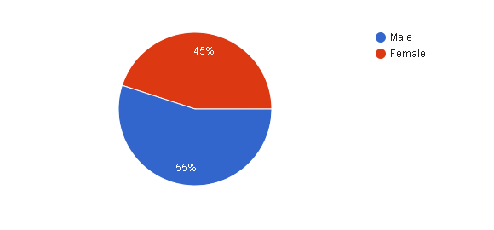

Figure Gender Pie-chart

The above pie-chart represent the distribution of male and female, it clears shows isn’t a disproportionate number of males over female or vice versa, fair distribution of male and female is important in-order to avoid gender bias.

Age

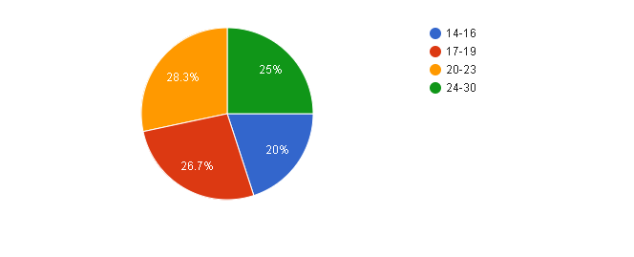

Figure Age Pie-chart

This is another crucial variable that should not be tilted toward one way or the other in-order to get a fairly random response from the sample. The above pie-chart clearly shows that there is a fair distribution of the different age groups.

### Level of study

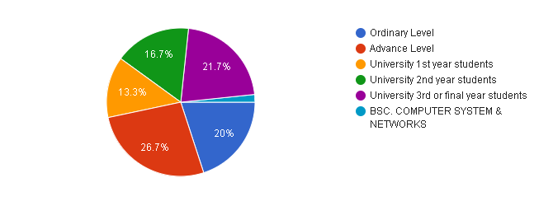

Figure Level of study Pie-Chart

The above pie-chart shows level of education of the students. Ordinary level, Advance level, University first year, University second year, and University third/final year students are the population. In-order for the study to be indicative there should be a fair distribution of the different educational levels. Above presented pie-chart represents that there is a fair distribution of the different educational levels.

### Education attained from

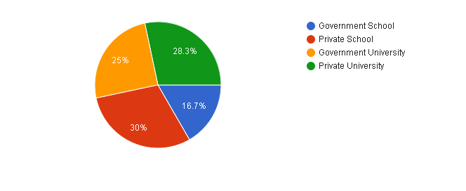

Figure Education attained from Pie-Chart

Above pie-chart shows that there is not a disproportionate number of government schools/university students over private school/university students or vice versa, it is important because the mentality of the different students could be different which could eventually lead into bias. As the above pie-chart represents there is fair distribution of students from both private and government sectors in-order to avoid bias.

## Descriptive statistics

The below table provides a summary of the independent and dependant variables. Mean, Standard deviation, first quartile, Median, and Third quartile values of the variable are given below.

|  |  |  |  |  |  |
| --- | --- | --- | --- | --- | --- |
| **Variable** | **Mean** | **Standard deviation** | **Q1** | **Median** | **Q3** |
| Education System | |  | | --- | | 3.6452 | |  | |  | |  | |  | | |  | | --- | | 0.6583 | |  | |  | | |  | | --- | | 3.2857 | |  | |  | | |  | | --- | | 3.7143 | |  | | |  | | --- | | 4.1429 | |  | |
| External factors | 3.2667 | 0.7498 | 2.5000 | 3.4000 | 3.8000 |
| Individual’s influence | 3.150 | 0.936 | 2.500 | 3.250 | 4.000 |
| Satisfaction | 3.258 | 0.941 | 2.500 | 3.250 | 4.000 |
| Motivation | 3.150 | 1.026 | 2.500 | 3.000 | 4.000 |

### Education System

|  |  |  |  |  |  |
| --- | --- | --- | --- | --- | --- |
| **Variable** | **Mean** | **Standard deviation** | **Q1** | **Median** | **Q3** |
| Education System | 3.6452 | 0.6583 | 3.2857 | 3.7143 | 4.1429 |

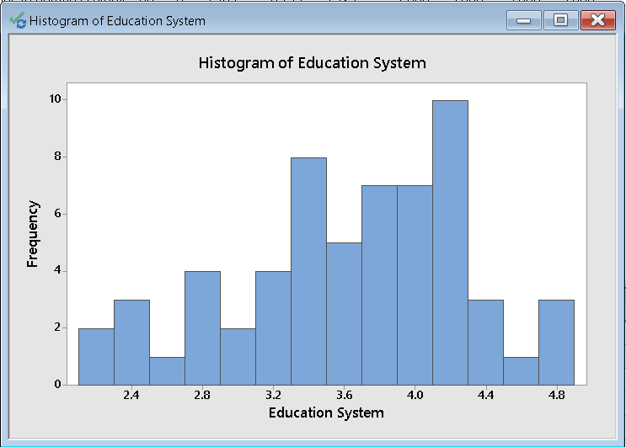

Figure Educations system Histogram

Histograms are used to show the frequency distribution, above histogram clearly shows the frequency of each values in the **education system** variable that is collected, according to the above histogram the value with the highest frequency is **4.1, 4.3**. The mean in the above table is **3.6452**. Values over **3** suggests that most of the students’ responses are towards agreeing the fact that they have faced difficulties because of the issues in the current education system.

### External factors

|  |  |  |  |  |  |
| --- | --- | --- | --- | --- | --- |
| **Variable** | **Mean** | **Standard deviation** | **Q1** | **Median** | **Q3** |
| External factors | 3.2667 | 0.7498 | 2.5000 | 3.4000 | 3.8000 |

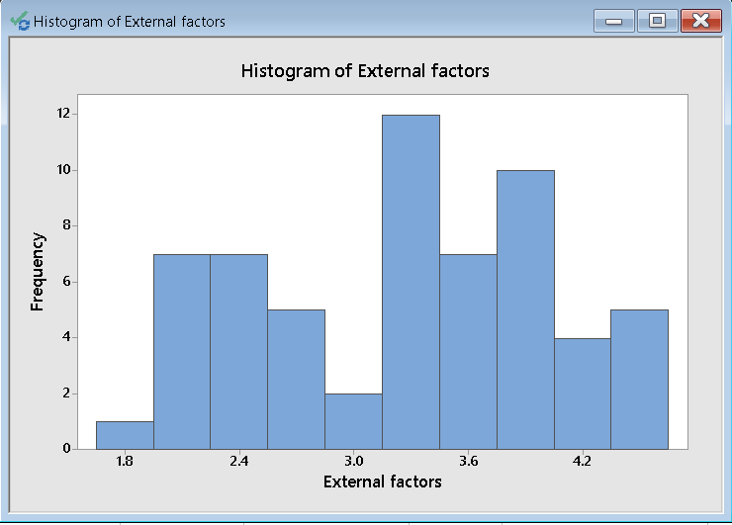

Figure External Factors Histogram

Above histogram clearly shows the frequency of each values in the **external factors** variable that is collected, according to the above histogram the value with the highest frequency is **3.15, 3.45**. The mean in the above table is **3.2667**. Values over **3** suggests that most of the students’ responses are towards agreeing the fact that external influence has had an influence on the selection of their major.

### Individual’s influence

|  |  |  |  |  |  |
| --- | --- | --- | --- | --- | --- |
| **Variable** | **Mean** | **Standard deviation** | **Q1** | **Median** | **Q3** |
| Individual’s influence | 3.150 | 0.936 | 2.500 | 3.250 | 4.000 |

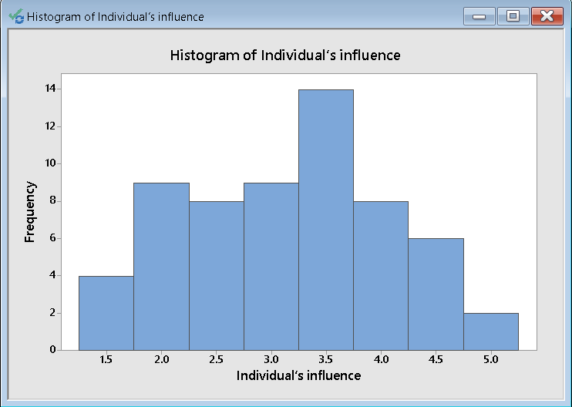

Figure Individual's influence Histogram

Above histogram clearly shows the frequency of each values in the **Individual’s influence** variable that is collected, according to the above histogram the value with the highest frequency is **3.25, 3.75**. The mean in the above table is **3.150**. Values over **3** suggests that most of the students’ responses are towards agreeing the fact that individuals’ influence has had an influence on the selection of their major.

.

### Satisfaction

|  |  |  |  |  |  |
| --- | --- | --- | --- | --- | --- |
| **Variable** | **Mean** | **Standard deviation** | **Q1** | **Median** | **Q3** |
| Change in human ecology | 3.258 | 0.941 | 2.500 | 3.250 | 4.000 |

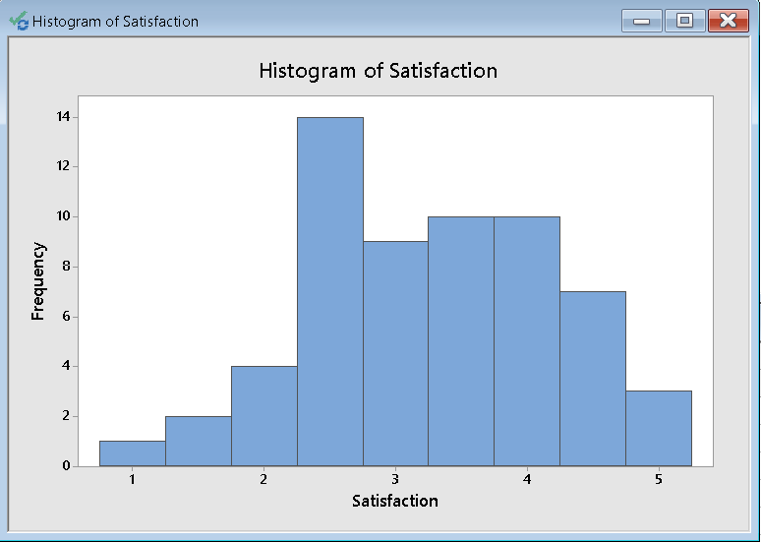

Figure Satisfaction Histogram

Above histogram clearly shows the frequency of each values in the **Satisfaction** variable that is collected, according to the above histogram the value with the highest frequency is **2.25, 2.75**. The mean in the above table is **3.258**. Here the mean is 3.258 which illustrates that the average response of the students’ is agreeing toward towards the fact that they are satisfied with their current state but it should be noted that the number of unsatisfied students are greater.

### Motivation

|  |  |  |  |  |  |
| --- | --- | --- | --- | --- | --- |
| **Variable** | **Mean** | **Standard deviation** | **Q1** | **Median** | **Q3** |
| Motivation | 3.150 | 1.026 | 2.500 | 3.000 | 4.000 |

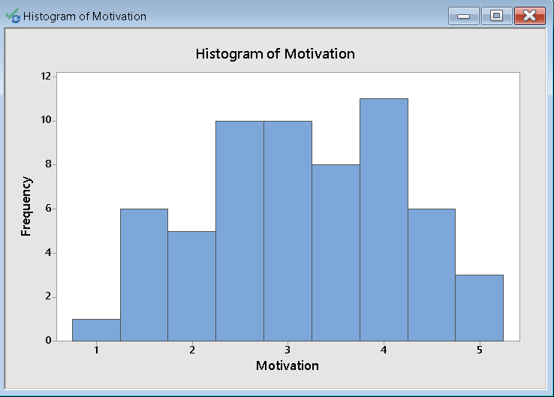

Figure Motivation Histogram

Above histogram clearly shows the frequency of each values in the **Motivation** variable that’s collected, according to the above histogram the value with the highest frequency is **3.75, 4.25**. The mean in the above table is **3.150**. Values over **3** suggests that most of the students seems to be motivated but it should be noted that there is a high number of less motivated students.

### Change in human ecology (Data collected to find out the number of students willing for a new human ecology)

|  |  |  |  |  |  |
| --- | --- | --- | --- | --- | --- |
| **Variable** | **Mean** | **Standard deviation** | **Q1** | **Median** | **Q3** |
| Change in human ecology | 3.383 | 1.121 | 3.000 | 4.000 | 4.000 |

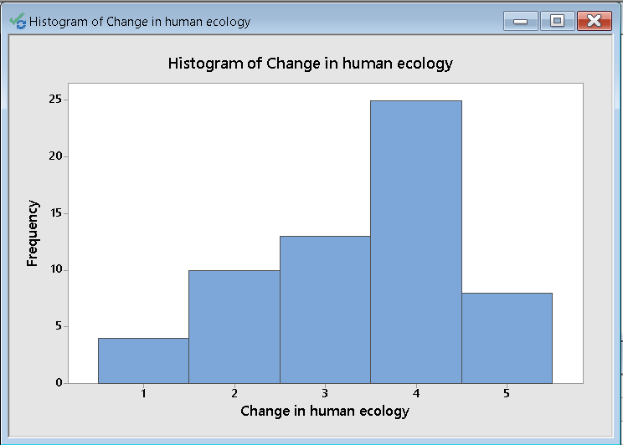

Figure Change in human ecology Histogram

Above histogram clearly shows the frequency of each values in the **Change in human ecology** that is collected, according to the above histogram the value with the highest frequency is **3.5, 4.5**. The mean in the above table is **3.383**. Values well over **3** suggests that most of the students’ responses are towards agreeing or strongly agreeing the fact that they are ready to accept a new human ecology that would assist them in the selection of major depending on their skills.

## Normality test for each Variables and change in human ecology.

We must check whether the variables Education system, External Factors, Individual’s influence, Satisfaction, and Motivation are normally distributed. Data collected to find whether students are willing for a change is human ecology is also checked for normal distribution. This can be done using Minitab, Anderson-Darling was used to test for normality.

### Education System

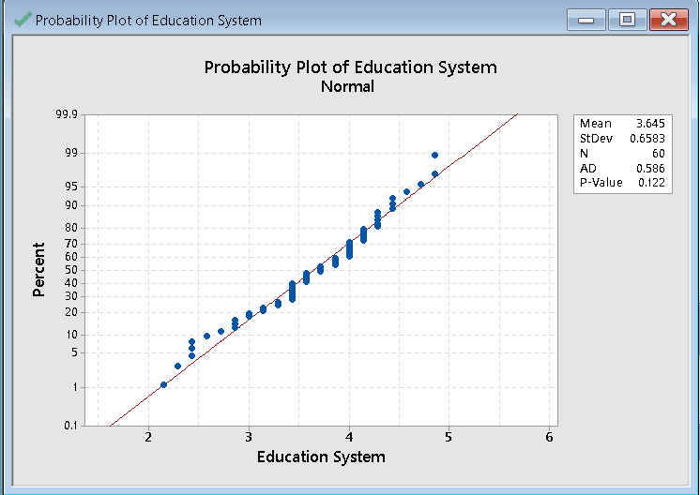

Figure Education System normality test

### External Factors

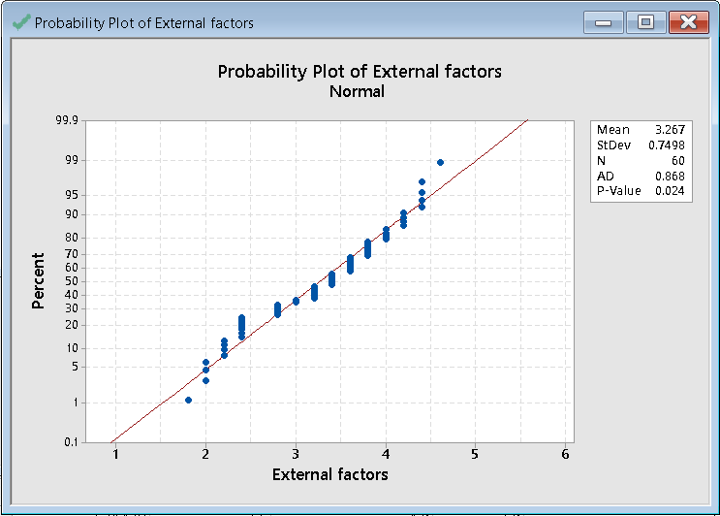

Figure External Factors normality test

### Individual’s influence

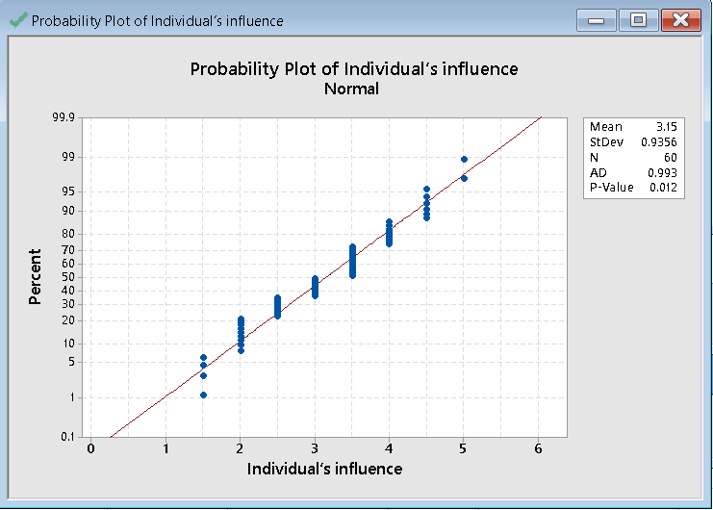

Figure Individual's influence normality test

### Satisfaction

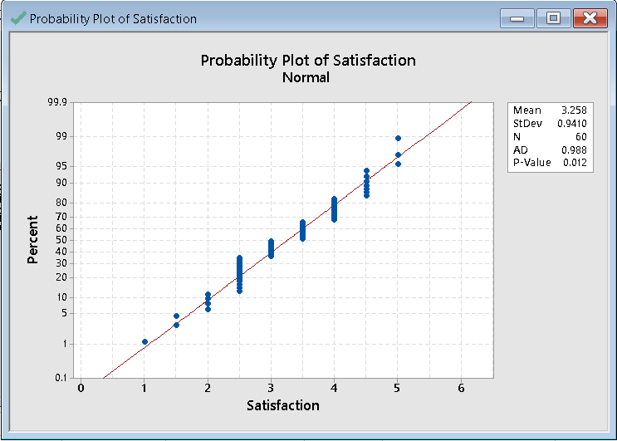

Figure Satisfaction normality test

### Motivation

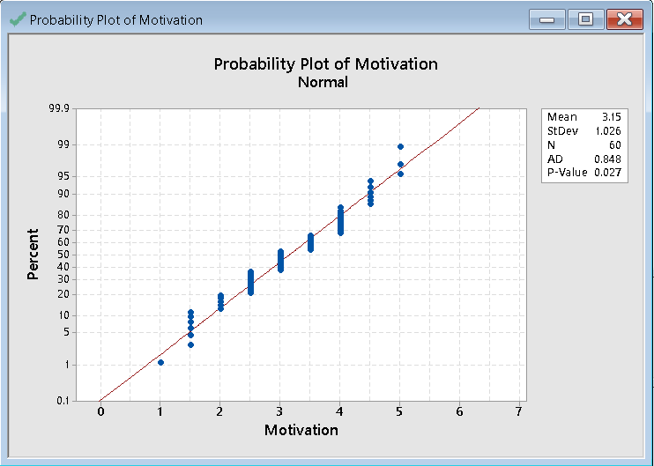

Figure Motivation normality test.

### Change in human ecology

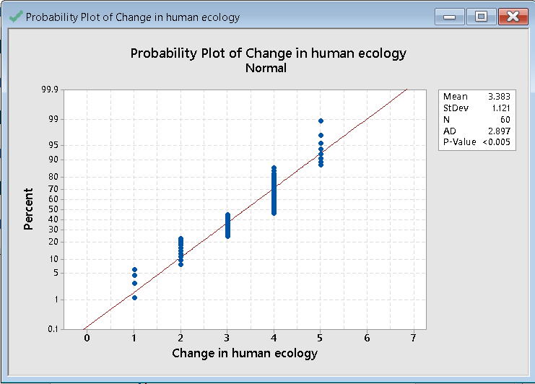

Figure Change in human ecology normality test

### Conclusion

Anderson-Darling normality test in Minitab was used to test for normality. The probability plot generated for each variable are given above. If we go through the P-values of each variables they are greater than the predefined significance level, which means that the null hypothesis is accepted.

H0: Data is normally distributed.

H1: Data is not normally distributed.

But data collected to find out the number of students willing for a new human ecology is skewed. Change in human ecology has a P-value which is less than the predefined significance level which is 0.005, which means an overwhelming number of students are willing for a change in human ecology this is the reason for the values to be skewed in the data collected to find out the number of students willing for a new human ecology.

## Testing Hypothesis

Hypothesis testing is done to conclude whether to accept or reject the null hypothesis. Hypothesis testing is part of the inferential analysis, this is done after the preliminary analysis. Results of the hypothesis testing done against the independent variables and the dependant variable can be found below.

### Motivation vs Education system

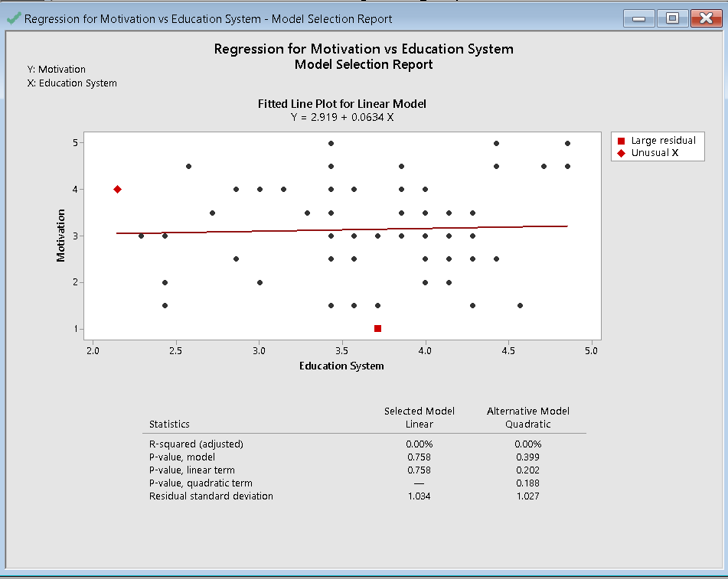

Figure Regression for Motivation vs Education System

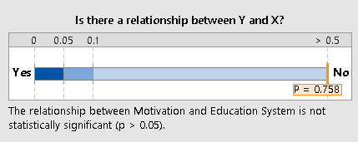

Figure Relationship between Motivation and Education System

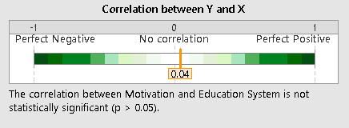

Figure Correlation between Motivation and Education System

The above charts clearly show that the relationship and correlation between the education system and motivation isn’t significant.

### Motivation vs External factors

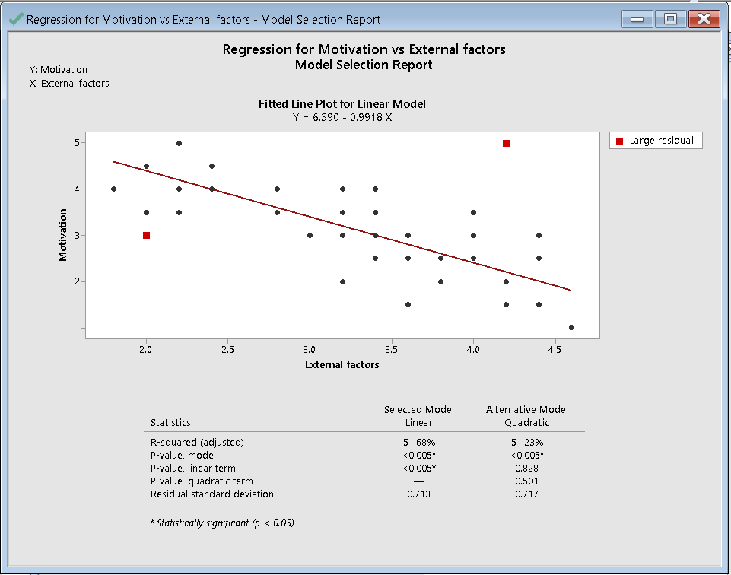

Figure Regression for Motivation vs External factors

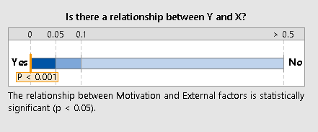

Figure Relationship between Motivation and External factors

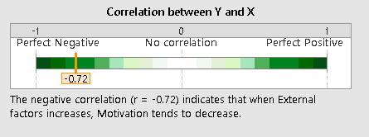

Figure Correlation between Motivation and External factors

Above charts clearly shows that there is a statistically significant relationship between motivation and external factors and there is a negative correlation between motivation and external factors.

### Motivation vs Individual’s influence

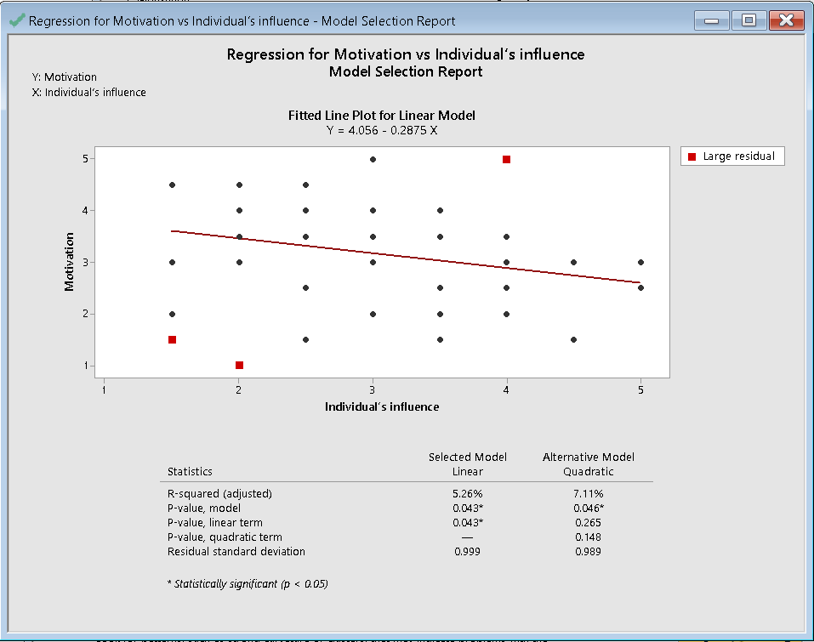

Figure Regression for Motivation vs Individual’s influence

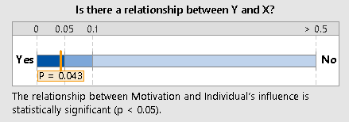

Figure Relationship between Motivation and Individual's influence

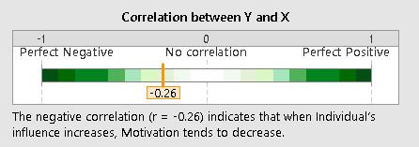

Figure Correlation n between Motivation and Individual's influence

Above charts clearly illustrates that there is a statistically significant relationship between Motivation and Individual’s influence and there is a negative correlation between Motivation and Individual’s influence.

### Motivation vs Satisfaction

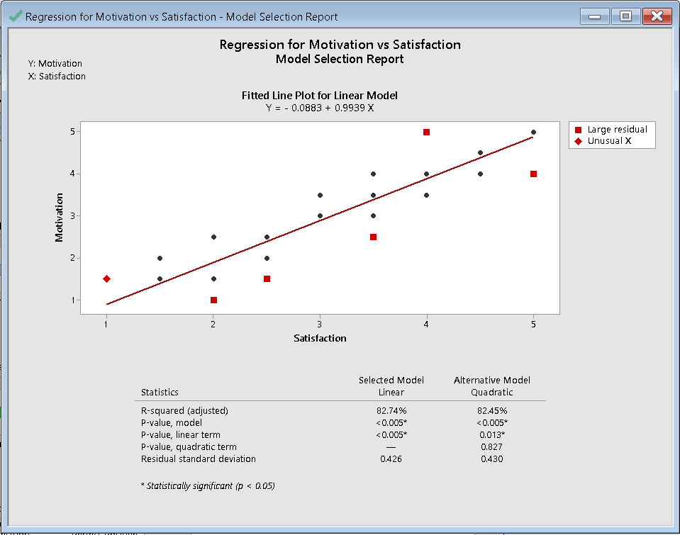

Figure Regression for Motivation vs Satisfaction

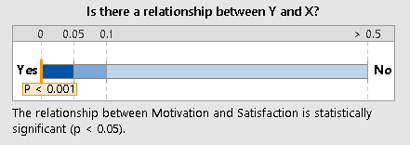

Figure Relationship between Motivation and satisfaction

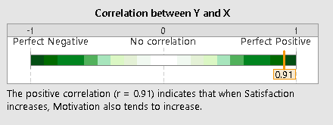

Figure Correlation between Motivation and satisfaction

Above charts clearly illustrates that there is a statistically significant relationship between Motivation and Satisfaction and there is a positive correlation between Motivation and Satisfaction.

### Summary of Hypothesis Testing

|  |  |  |  |
| --- | --- | --- | --- |
| **Number** | **Hypothesis** | **Confidence Level** | **Accept/Reject** |
| **H1** | **H10: Issues in the education system has no negative impact on student’s motivational levels**  **H11: Issues in the education system has negative impact on student’s motivational levels** | 95% (α = 0.05) | Accepted  Rejected |
| **H2** | **H20: External factors has no negative impact on students’ motivation**  **H21: External factors has a negative impact on students’ motivation** | 95% (α = 0.05) | Rejected  Accepted |
| **H3** | **H30: Individuals’ influence has no negative impact on the students’ motivation**  **H31: Individuals’ influence can have a negative impact on the students’ motivation** | 95% (α = 0.05) | Rejected  Accepted |
| **H4** | **H40: Satisfaction at the current state has no positive impact on motivation of students**  **H41: Satisfaction at the current state has a positive impact on motivation of students** | 95% (α = 0.05) | Rejected  Accepted |

# Chapter 5: Conclusion and Recommendation

## Introduction

This chapter is encompassed of the conclusion and recommendations for this research study. This research study was done in-order to find out the factors that motivate students pursue in a particular major. Most of the factors identified that determine students’ major selection are irrational, this is mainly because there is not a sound methodology available for the students when it comes to the selection of major. During the research study it was found out that an overwhelming number of students are willing to accept a new human ecology that would help them select the most appropriate major depending on their skills and talent. Histogram in the previous chapter clearly shows that the highest frequency in the Change in human ecology is 3.5, 4.5 and a mean value of 3.383, which suggests that most of the students’ responses are towards agreeing or strongly agreeing the fact that they are ready to accept a new human ecology that would assist them in the selection of major depending on their skills.

Preliminary analysis done in the previous chapter proves that the data collected for this study has a good mixture of gender, age groups, education levels, and student form different schools/universities, which is important for the quality of the sample in-order to avoid possible biases.

Histograms of the independent variable education system suggests that most of the students’ responses are towards agreeing the fact that they have faced difficulties because of the issues in the current education system. Histograms of the independent variable external factors suggests that most of the students’ responses are towards agreeing the fact that external influence has had an influence on the selection of their major. Histogram of the independent variable individual’s influence suggests that most of the students’ responses are towards agreeing the fact that individuals’ influence has had an influence on the selection of their major. Histogram of the independent variable satisfaction illustrates that the average response of the students’ is agreeing toward towards the fact that they are satisfied with their current state but it should be noted that the number of unsatisfied students are greater. Histogram of the dependant variable motivation suggests that most of the students seems to be motivated but there is a high number of less motivated students as well.

Anderson-Darling test using Minitab was done for the different independent variables and the dependant variable to test for normality. The variables were found to be normally distributed which was important in-order to start the advance analysis.

Hypothesis testing proved that there was not a significant relationship between education system and motivation and there is no correlation between the education system and motivation. So, we can conclude that most of the student have been negatively impacted because of the issues in the education system yet the issues in the education system haven’t impacted their motivation according to this study.

There was a significant relationship and a strong negative correlation between external factors and motivation which suggest that students who were influenced by external factors such as reputation, high demand, financial status, and etc. when it comes to the selection of their major or making other educational decisions have low motivation.

Students often make their educational decisions due to individual’s influence, there was a significant relationship and a negative correlation between motivation and individual’s influence which suggests that students who have made educational decisions based on individual’s influence and lacked in motivation to make better decisions.

Finally, hypothesis testing was done for the independent variable satisfaction there was significant relationship and a very strong positive correlation between motivation and satisfaction which suggest the students who are satisfied at the current state have a high level of motivation. So we can come to a conclusion that in-order for a student to be comfortable and motivated there should be a methodology to assist the students when it comes to selection of major rather than making decisions based on irrational a factors.

## Recommendation

Considering the findings of this research study it is strongly recommended to implement Artificial intelligence in education. Because the research study clearly illustrates that students have often lacked motivation in-order to progress forward because they must look upon irrational factors when it comes to making educational decision. Using AIED (Artificial intelligence in education) has the potential of having an impact on the students in several ways such as.

* Provide students customized materials: students are often treated the same, which could not work for most of the students.
* Analyze students’ test: Tests are often summative used to monitor the students, but tests should be diagnostic, in other words analyse and help students improve by covering the gaps.
* Provide major options: Often several factors determine student major selection, because of the unavailability of a proper mechanism to guide the students.

If implementation of Artificial intelligence is not feasible the schools, universities, should start having dedicated departments to assist students when it comes to making educational decisions.